Sunnytrails service unit and Alpha Phi Alpha Zeta Sigma Lambda invites you to participate in the 33rd annual
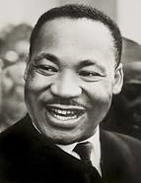Dr. Martin Luther King Jr. Parade
Sunday, January 19, 2014 @ 2pm
Bring your bells and let your “FREEDOM” ring
Fee is $ 5.00 Per Registered Girl Scout
Included are the parade entrance, patch, water, and snack
*Parade begins on Grape St. and ends on Harbor Drive*
(Embarcadero Area) Parade Route located on the back
*Approximate line up time will be 12pm*

Limited to first 200 girls, sign up early! We ask that all troops march with safety wise adults only. Deadline for sign-ups is 01/10/2014

*Details for meeting place and time will be sent via e-mail a week prior to event*
Questions? Contact Dovanah Jordan at gstroop6386@gmail.com
-------------------------------------------------------------------------------------------Leader name________________________ Troop #________ Level (circle) D B J C S A
Phone #__________________e-mail address_________________________________
Number of girls____________ x $5.00 ea. (no charge for adults) Total______________
Make checks payable to Girl Scouts Sunnytrails Service Unit.

Troop checks only/no personal checks please

Mail to: Dovanah Jordan, 1251 Jamestown Drive
Chula Vista, CA 91913
Parade Route
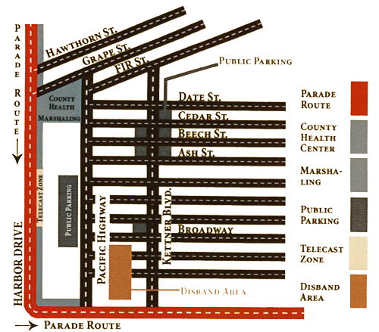
Parade route is approximately 1 1/3 miles long

