TROOP 6114 PRESENTS
DAY OF THE DEAD CELEBRATION
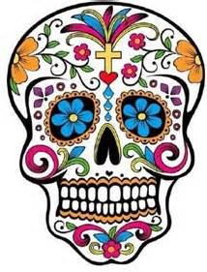
Decorate
Sugar Skulls

Learn the traditions
& significance of
this festive day

Make corn husk dolls

Make colorful
paper flowers

Face painting

Sample pan de muerto

DATE: | Saturday, October 21st
TIME: | 12:00-2:00pm
PLACE: |  |  | San Diego Girl Scouts – Balboa Property
Florence Burnham Hall
COST: |  | $15 per girl. All ages welcome  *patch not included*

Contact gstroop6114@gmail.com to reserve your spot!

Take Action Project- Please help our troop collect socks for those in need. Each girl that brings in 2 pair (or more) will receive a patch for our Day of the Dead event.

